The Japanese 5S Methodology

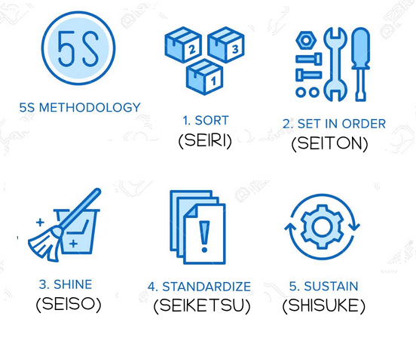
Five disciplines for high workplace productivity

